**LAB 9-10: NANOPROCESSOR DESIGN**

**LAB REPORT**

CS1050 Computer Organization and Digital Design

**Team 30**

**H.M.M.M.Herath 230242A**

**J.M.A.N.N.Jayamanne 230272N**

**J.M.T.D Chandrasiri 230101R**

**M.U.A Ahamed 230025L**

**INTRODUCTION**

In this lab, we designed and implemented a 4-bit nano processor capable of executing 4 basic instructions, providing digital logic design, processor architecture, and hardware description language (VHDL) programming. The project involved constructing a simplified yet fully functional processor from the ground up, integrating key components such as arithmetic logic units (ALUs), registers, multiplexers, and control logic. The final design was simulated for correctness using XSim and deployed on a BASYS 3 FPGA board for real-world validation.

**Nano-processor Architecture**

The nano-processor consists of the following components:

1. **Register Bank**
   * Comprises eight 4-bit registers (R0–R7), with R0 hardwired to zero for use in operations like negation (NEG) and conditional jumps (JZR).
   * Implements tri-state buffers for controlled data flow, ensuring only one register drives the bus simultaneously.
2. **4-bit Add/Subtract Unit**
   * Built using a ripple-carry adder (RCA) with 2’s complement arithmetic for signed number operations.
   * Detects overflow and output flags for error handling.
3. **Program Counter (PC)** 
   * A 3-bit synchronous counter with reset functionality, allowing program restart via a pushbutton.
   * Supports conditional jumps (JZR) by checking if a register’s value is zero.
4. **Instruction Decoder**
   * Translates 12-bit machine code into control signals for:
     + Using register enable (RRR), only the required register should be enabled
     + For ADD and NEG instructions, relevant inputs are selected from the multiplexers, and the output is sent to the correct register.
     + ALU operation mode (add/subtract)
     + Program flow control (Address to jump or increment the Program Counter)
5. **Program ROM**
   * Store the assembly programs.
   * Implemented as a lookup table (LUT) in VHDL, preloaded with instructions.
6. **Data Path & Multiplexers**
   * Uses 8-way 4-bit multiplexers to route data between registers and the ALU.
   * A 2-way 3-bit multiplexer controls the PC’s next address (increment or jump).

**Implementation & Verification**

1. **Simulation (XSim)**
   * Verified correct register updates, ALU operations, and branching.
   * Checked overflow handling in signed arithmetic.
2. **FPGA Deployment (BASYS 3)**
   * Connected R7 output to LEDs and 7-segment display for real-time monitoring.
   * Used 7-segment display for debugging.
   * Implemented a slow clock (~0.5 Hz) for step-by-step execution visibility.

**Team Contributions**

| **Team Member** | **Role** | **Key Contributions** |
| --- | --- | --- |
| Member 1 | ALU Design | 4-bit RCA, overflow detection |

**Additional Features**

We have enabled two seven segment displays so we can show the negative sign. Thereby enabling us to display the values of Register 7 ranging from -8 to +7. We have also added an extra Program to the ROM with the R7 showing a negative value and also the program is running in an infinite loop.

We introduced two features to improve functionality and user interactivity. Firstly, we used two 7-segment displays to represent negative values stored in Register 7. Instead of displaying only positive values, our design utilizes two of the available 7-segment displays, where the first digit display the absolute value of the number in decimal, and the second digit conditionally shows a minus sign if the value is negative. This dual-display approach offers clear, intuitive feedback for interpreting signed numbers. Secondly, we implemented support for an additional program that runs independently when the change_program signal is activated. This secondary program is specifically designed to display the sign handling capability, operating within an infinite loop. Together, these enhancements significantly improve the usability and debugging transparency of the Nanoprocessor system.

**Resource Utilization Reports**

**Minimal Requirements**

**With Additional Features**

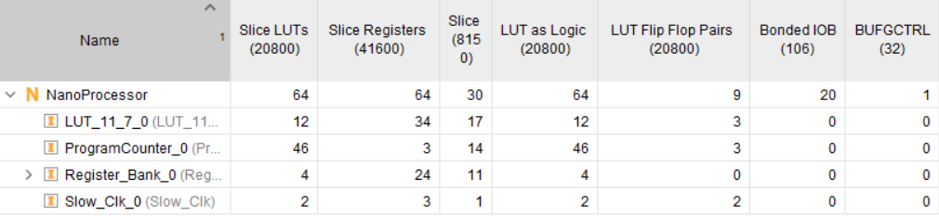

**Team Contribution**

**J.M.A.N.N.Jayamanne**

**Assembly Program**

MOVI R7,3 => R7=3 (Move the value 3 to register 7)

MOVI R1,1 => R1=1(Move the value 1 to register 1)

NEG R1 => R1=-1 (Make register 1’s value negative)

MOVI R2,2 => R2=2 (Move the value 2 to register 2)

ADD R7,R2 => R7=5 (Add values in Register 7 and 2 and save the answer in register 7)

ADD R2,R1 => R2=1 (Add values in Register 2 and 1 and save the in register 7)

ADD R7,R2 => R7=6 (Add values in Register 7 and 2 and save the answer in register 7)

JZR R0,7 => (Goes to the 7th instruction if R0==0 which is not, so program will stay on the 7th instruction)

**Machine Code**

"101110000011"

"100010000001"

"010010000000"

"100100000010"

"001110100000"

"000100010000"

"001110100000"

"110000000111"

In the machine code representation, each line represents a single instruction encoded in binary. The first two bits usually denote the opcode, followed by the necessary register address, operand or immediate value if applicable. These machine code instructions are what the processor executes directly.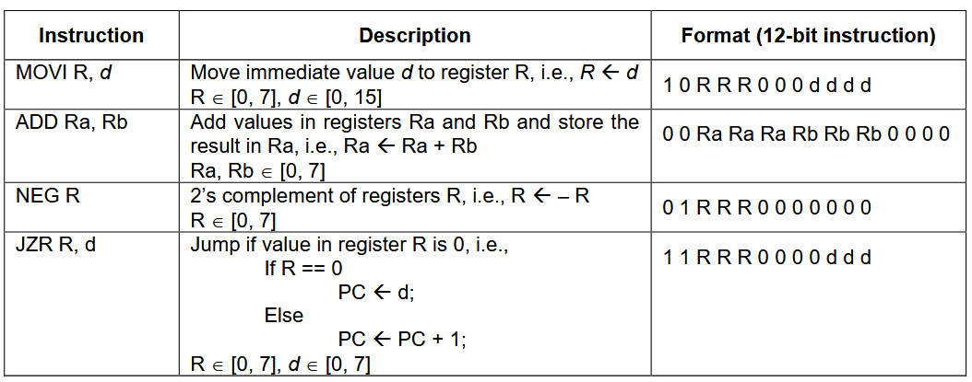

**Strategies Used to Optimize resource consumption**

**Overall design**

In this design, we optimized resource utilization by using a 2 bit unsigned signal instead of a larger integer which use a 32 bit counter. This significantly reduces the number of flip-flops required for implementation in hardware, minimizing area and power consumption. By adjusting the bit width to the minimum needed for the desired frequency division (in this case, toggling the output after counting to 3), we achieve an efficient design that conserves FPGA resources while maintaining the intended clock slowing functionality.

**3-bit Adder**

In this 3 bit adder design, we optimized the circuit by avoiding a traditional ripple carry adder and instead implemented a custom incrementor. Since our requirement was only to add 1 to the 3 bit input R, we used simple combinational logic to generate the output Y directly. This approach uses just 2 XOR gates, 1 AND gate, and 1 NOT gate, compared to a ripple carry adder which would typically require 3 full adders, each consisting of multiple XOR, AND, and OR gates. Overall, this significantly reduces the total number of logic gates used, leading to a smaller, faster, and more power efficient design tailored specifically for incrementing by 1.

**Design sources**

**NanoProcessor.VHDL**

library IEEE;

use IEEE.STD_LOGIC_1164.ALL;

use work.Reg_types.all;

entity NanoProcessor is

Port ( Clk : in STD_LOGIC;

change_program : in STD_LOGIC;

Reset : in STD_LOGIC;

LED : out STD_LOGIC_VECTOR (3 downto 0);

S_7seg : out STD_LOGIC_VECTOR (6 downto 0);

anode : out STD_LOGIC_VECTOR (3 downto 0);

Overflow : out STD_LOGIC;

Zero : out STD_LOGIC);

end NanoProcessor;

architecture Behavioral of NanoProcessor is

component Slow_Clk is

Port ( Clk_in : in STD_LOGIC;

Clk_Out : out STD_LOGIC);

end component;

component ProgramCounter is

Port ( D : in STD_LOGIC_VECTOR (2 downto 0);

Res : in STD_LOGIC;

Clk : in STD_LOGIC;

Q : out STD_LOGIC_VECTOR (2 downto 0));

end component;

component Program_ROM is

Port ( address : in STD_LOGIC_VECTOR (2 downto 0);

change_program : in STD_LOGIC;

data : out STD_LOGIC_VECTOR (11 downto 0));

end component;

component Instruction_Decoder is

Port ( Instruction_Bus : in STD_LOGIC_VECTOR (11 downto 0);

Register_enable : out STD_LOGIC_VECTOR (2 downto 0);

Load_select : out STD_LOGIC;

Immediate_value : out STD_LOGIC_VECTOR (3 downto 0);

Register_select_A : out STD_LOGIC_VECTOR (2 downto 0);

Register_select_B : out STD_LOGIC_VECTOR (2 downto 0);

Neg : out STD_LOGIC;

Reg_check_jmp : in STD_LOGIC_VECTOR (3 downto 0);

jmp_flag : out STD_LOGIC;

jmp_addr : out STD_LOGIC_VECTOR (2 downto 0));

end component;

component Register_Bank is

Port ( Clk : in STD_LOGIC;

Reg_EN : in STD_LOGIC_VECTOR (2 downto 0);

Reset : in STD_LOGIC;

input : in STD_LOGIC_VECTOR (3 downto 0);

Data_Bus : out Reg_array);

end component;

component Mux_8_to_4 is

Port ( R0 : in STD_LOGIC_VECTOR (3 downto 0);

R1 : in STD_LOGIC_VECTOR (3 downto 0);

R2 : in STD_LOGIC_VECTOR (3 downto 0);

R3 : in STD_LOGIC_VECTOR (3 downto 0);

R4 : in STD_LOGIC_VECTOR (3 downto 0);

R5 : in STD_LOGIC_VECTOR (3 downto 0);

R6 : in STD_LOGIC_VECTOR (3 downto 0);

R7 : in STD_LOGIC_VECTOR (3 downto 0);

Sel : in STD_LOGIC_VECTOR (2 downto 0);

M8_4_out : out STD_LOGIC_VECTOR (3 downto 0));

end component;

component bit4_Add_Sub_Unit is

Port ( A : in STD_LOGIC_VECTOR (3 downto 0);

B : in STD_LOGIC_VECTOR (3 downto 0);

Neg : in STD_LOGIC;

S : out STD_LOGIC_VECTOR (3 downto 0);

Overflow : out STD_LOGIC;

Zero : out STD_LOGIC);

end component;

component Mux_2_to_4 is

Port ( B0 : in STD_LOGIC_VECTOR (3 downto 0);

B1 : in STD_LOGIC_VECTOR (3 downto 0);

LoadSel : in STD_LOGIC;

M2_4_out : out STD_LOGIC_VECTOR (3 downto 0));

end component;

component Mux_2_to_3 is

Port ( A0 : in STD_LOGIC_VECTOR (2 downto 0);

A1 : in STD_LOGIC_VECTOR (2 downto 0);

JMP_FLAG : in STD_LOGIC;

M2_3_out : out STD_LOGIC_VECTOR (2 downto 0));

end component;

component bit3_Adder is

Port ( R : in STD_LOGIC_VECTOR (2 downto 0);

Y : out STD_LOGIC_VECTOR (2 downto 0));

end component;

component LUT_11_7 is

Port ( Clk : in STD_LOGIC;

number : in STD_LOGIC_VECTOR (3 downto 0);

anode : out STD_LOGIC_VECTOR (3 downto 0);

S_7seg : out STD_LOGIC_VECTOR (6 downto 0));

end component;

signal pc_out, pc_in : STD_LOGIC_VECTOR (2 downto 0);

signal slw_clk : std_logic;

signal Instruction_Bus : STD_LOGIC_VECTOR (11 downto 0);

signal Register_enable : STD_LOGIC_VECTOR (2 downto 0);

signal Load_select : std_logic;

signal Immediate_value : STD_LOGIC_VECTOR (3 downto 0);

signal Register_select_A, Register_select_B : STD_LOGIC_VECTOR (2 downto 0);

signal Neg : std_logic;

signal jmp_flag : std_logic;

signal jmp_addr : STD_LOGIC_VECTOR (2 downto 0);

signal Data : STD_LOGIC_VECTOR (3 downto 0);

signal Data_Bus : Reg_array;

signal M8_4_out_A, M8_4_out_B : STD_LOGIC_VECTOR (3 downto 0);

signal S : STD_LOGIC_VECTOR (3 downto 0);

signal next_addr : STD_LOGIC_VECTOR (2 downto 0);

begin

Slow_Clk_0 : Slow_Clk

Port map ( Clk_in => Clk,

Clk_Out => slw_clk);

ProgramCounter_0 : ProgramCounter

Port map ( D => pc_in,

Res => Reset,

Clk => slw_clk,

Q => pc_out);

Program_ROM_0 : Program_ROM

Port map ( address => pc_out,

change_program => change_program,

data => Instruction_Bus);

Instruction_Decoder_0 : Instruction_Decoder

Port map ( Instruction_Bus => Instruction_Bus,

Register_enable => Register_enable,

Load_select => Load_select,

Immediate_value => Immediate_value,

Register_select_A => Register_select_A,

Register_select_B => Register_select_B,

Neg => Neg,

Reg_check_jmp => M8_4_out_A,

jmp_flag => jmp_flag,

jmp_addr => jmp_addr);

Register_Bank_0 : Register_Bank

Port map ( Clk => slw_clk,

Reg_EN => Register_enable,

Reset => Reset,

input => Data,

Data_Bus => Data_Bus);

Mux_8_to_4_A : Mux_8_to_4

Port map ( R0 => Data_Bus(0),

R1 => Data_Bus(1),

R2 => Data_Bus(2),

R3 => Data_Bus(3),

R4 => Data_Bus(4),

R5 => Data_Bus(5),

R6 => Data_Bus(6),

R7 => Data_Bus(7),

Sel => Register_select_A,

M8_4_out => M8_4_out_A);

Mux_8_to_4_B : Mux_8_to_4

Port map ( R0 => Data_Bus(0),

R1 => Data_Bus(1),

R2 => Data_Bus(2),

R3 => Data_Bus(3),

R4 => Data_Bus(4),

R5 => Data_Bus(5),

R6 => Data_Bus(6),

R7 => Data_Bus(7),

Sel => Register_select_B,

M8_4_out => M8_4_out_B);

bit4_Add_Sub_Unit_0 : bit4_Add_Sub_Unit

Port map ( A => M8_4_out_A,

B => M8_4_out_B,

Neg => Neg,

S => S,

Overflow => Overflow,

Zero => Zero);

Mux_2_to_4_0 : Mux_2_to_4

Port map ( B0 => S,

B1 => Immediate_value,

LoadSel => Load_select,

M2_4_out => Data);

Mux_2_to_3_0 : Mux_2_to_3

Port map ( A0 => next_addr,

A1 => jmp_addr,

JMP_FLAG => jmp_flag,

M2_3_out => pc_in);

bit3_Adder_0 : bit3_Adder

Port map ( R => pc_out,

Y => next_addr);

LUT_11_7_0 : LUT_11_7

Port map ( Clk => Clk,

number => Data_Bus(7),

anode => anode,

S_7seg => S_7seg);

LED <= Data_Bus(7);

end Behavioral;

**Slow_Clk.VHDL**

library IEEE;

use IEEE.STD_LOGIC_1164.ALL;

use IEEE.NUMERIC_STD.ALL;

entity Slow_Clk is

Port ( Clk_in : in STD_LOGIC;

Clk_Out : out STD_LOGIC);

end Slow_Clk;

architecture Behavioral of Slow_Clk is

signal count : unsigned(25 downto 0) := "00000000000000000000000000";

signal clk_status : std_logic :='0';

begin

Clk_out <= clk_status;

process (clk_in) begin

if(rising_edge(Clk_in)) then

count <= count + 1;

if(count = "10111110101111000010000000") then

clk_status <= not clk_status;

count <= "00000000000000000000000000";

end if;

end if;

end process;

end Behavioral;

**ProgramCounter.VHDL**

library IEEE;

use IEEE.STD_LOGIC_1164.ALL;

entity ProgramCounter is

Port ( D : in STD_LOGIC_VECTOR (2 downto 0):= "000";

Res : in STD_LOGIC;

Clk : in STD_LOGIC;

Q : out STD_LOGIC_VECTOR (2 downto 0):= "000");

end ProgramCounter;

architecture Behavioral of ProgramCounter is

begin

-- Here we have modified the code used in Lab 5. Instead of using DFFs, a bus is used.

process(Clk) begin

if(rising_edge(Clk)) then

if(Res ='1') then

Q <= "000";

else

Q <= D;

end if;

end if;

end process;

end Behavioral;

**Program_ROM.VHDL**

library IEEE;

use IEEE.STD_LOGIC_1164.ALL;

use ieee.numeric_std.all;

entity Program_ROM is

Port ( address : in STD_LOGIC_VECTOR (2 downto 0);

change_program : in STD_LOGIC:='0';

data : out STD_LOGIC_VECTOR (11 downto 0));

end Program_ROM;

architecture Behavioral of Program_ROM is

type rom_type is array (0 to 7) of std_logic_vector(11 downto 0);

signal First_Program : rom_type := (

"101110000011", --MOVI R7,3 => R7=3

"100010000001", --MOVI R1,1 => R1=1

"010010000000", --NEG R1 => R1=-1

"100100000010", --MOVI R2,2 => R2=2

"001110100000", --ADD R7,R2 => R7=5

"000100010000", --ADD R2,R1 => R2=1

"001110100000", --ADD R7,R2 => R7=6

"110000000111" --JZR R0,7 => GOES TO 7th INSTRUCTION IF R0==0 WHICH IS NOT

);

signal Second_Program : rom_type:=(

"101110000001", --MOVI R7,1 => R7=1

"101010000010", --MOVI R5,2 => R5=2

"011110000000", --NEG R7 => R7=-1

"101100000011", --MOVI R6,3 => R6=3

"001111010000", --ADD R7,R5 => R7=1

"001111100000", --ADD R7,R6 => R7=4

"011110000000", --NEG R7 => R7=-4

"110000000000" --JZR R0,0 => GOES TO 0th instruction if R0==0 which is not

);

begin

process(change_program,address)

begin

if change_program ='1' then

data <= Second_Program(to_integer(unsigned(address)));

else

data <= First_Program(to_integer(unsigned(address)));

end if;

end process;

end Behavioral;

**Instruction_Decoder.VHDL**

library IEEE;

use IEEE.STD_LOGIC_1164.ALL;

entity Instruction_Decoder is

Port ( Instruction_Bus : in STD_LOGIC_VECTOR (11 downto 0);

Register_enable : out STD_LOGIC_VECTOR (2 downto 0);

Load_select : out STD_LOGIC;

Immediate_value : out STD_LOGIC_VECTOR (3 downto 0);

Register_select_A : out STD_LOGIC_VECTOR (2 downto 0);

Register_select_B : out STD_LOGIC_VECTOR (2 downto 0);

Neg : out STD_LOGIC;

Reg_check_jmp : in STD_LOGIC_VECTOR (3 downto 0);

jmp_flag : out STD_LOGIC;

jmp_addr : out STD_LOGIC_VECTOR (2 downto 0));

end Instruction_Decoder;

architecture Behavioral of Instruction_Decoder is

begin

Register_enable <= Instruction_Bus(9 downto 7);

Load_select <= Instruction_Bus(11);

Immediate_value <= Instruction_Bus(3 downto 0);

Register_select_A <= Instruction_Bus(9 downto 7);

Register_select_B <= Instruction_Bus(6 downto 4);

Neg <= Instruction_Bus(10);

jmp_flag <= '1' when Reg_check_jmp = "0000" and Instruction_Bus(11 downto 10) = "11" else '0';

jmp_addr <= Instruction_Bus(2 downto 0);

end Behavioral;

**Register_Bank.VHDL**

library IEEE;

use IEEE.STD_LOGIC_1164.ALL;

use work.Reg_types.all;

entity Register_Bank is

Port ( Clk : in STD_LOGIC;

Reg_EN : in STD_LOGIC_VECTOR (2 downto 0);

Reset : in STD_LOGIC;

input : in STD_LOGIC_VECTOR (3 downto 0);

Data_Bus : out Reg_array);

end Register_Bank;

architecture Behavioral of Register_Bank is

component Decoder_3_to_8

Port ( I : in STD_LOGIC_VECTOR (2 downto 0);

EN : in STD_LOGIC := '1';

Y : out STD_LOGIC_VECTOR (7 downto 0));

end component;

component Reg

Port ( D : in STD_LOGIC_VECTOR (3 downto 0);

EN : in STD_LOGIC;

Clk : in STD_LOGIC;

Q : out STD_LOGIC_VECTOR (3 downto 0));

end component;

signal Reg_EN_out : STD_LOGIC_VECTOR (7 downto 0);

signal Input_line : STD_LOGIC_VECTOR (3 downto 0);

signal Data_Buses : Reg_array;

begin

Input_line <= "0000" when ( Reset='1' ) else input;

Decoder : Decoder_3_to_8

port map(

I=>Reg_EN,

Y=>Reg_EN_out);

Reg_0 : Reg

port map(

D=>"0000",

EN=>'1',

Clk =>Clk,

Q=>Data_Buses(0));

gen_regs: for i in 1 to 7 generate

reg_inst: Reg

port map (

D => Input_line,

EN => Reg_EN_out(i),

Clk => Clk,

Q=>Data_Buses(i));

end generate;

Data_Bus <= Data_Buses;

end Behavioral;

**Reg.VHDL**

library IEEE;

use IEEE.STD_LOGIC_1164.ALL;

entity Reg is

Port ( D : in STD_LOGIC_VECTOR (3 downto 0);

EN : in STD_LOGIC;

Clk : in STD_LOGIC;

Q : out STD_LOGIC_VECTOR (3 downto 0));

end Reg;

architecture Behavioral of Reg is

begin

process (Clk) begin

if (rising_edge (Clk)) then

if EN = '1' then

Q<=D;

end if;

end if;

end process;

end Behavioral;

**Mux_8_to_4.VHDL**

library IEEE;

use IEEE.STD_LOGIC_1164.ALL;

entity Mux_8_to_4 is

Port ( R0 : in STD_LOGIC_VECTOR (3 downto 0);

R1 : in STD_LOGIC_VECTOR (3 downto 0);

R2 : in STD_LOGIC_VECTOR (3 downto 0);

R3 : in STD_LOGIC_VECTOR (3 downto 0);

R4 : in STD_LOGIC_VECTOR (3 downto 0);

R5 : in STD_LOGIC_VECTOR (3 downto 0);

R6 : in STD_LOGIC_VECTOR (3 downto 0);

R7 : in STD_LOGIC_VECTOR (3 downto 0);

Sel : in STD_LOGIC_VECTOR (2 downto 0);

M8_4_out : out STD_LOGIC_VECTOR (3 downto 0));

end Mux_8_to_4;

architecture Behavioral of Mux_8_to_4 is

begin

M8_4_out <= R0 when Sel = "000" else

R1 when Sel = "001" else

R2 when Sel = "010" else

R3 when Sel = "011" else

R4 when Sel = "100" else

R5 when Sel = "101" else

R6 when Sel = "110" else

R7 when Sel = "111" else

(others => 'U');

end Behavioral;

**MUX_2_to_4.VHDL**

library IEEE;

use IEEE.STD_LOGIC_1164.ALL;

entity Mux_2_to_4 is

Port ( B0 : in STD_LOGIC_VECTOR (3 downto 0);

B1 : in STD_LOGIC_VECTOR (3 downto 0);

LoadSel : in STD_LOGIC;

M2_4_out : out STD_LOGIC_VECTOR (3 downto 0));

end Mux_2_to_4;

architecture Behavioral of Mux_2_to_4 is

begin

M2_4_out <= B0 when LoadSel = '0' else B1;

end Behavioral;

**MUX_2_to_3.VHDL**

library IEEE;

use IEEE.STD_LOGIC_1164.ALL;

entity Mux_2_to_3 is

Port ( A0 : in STD_LOGIC_VECTOR (2 downto 0);

A1 : in STD_LOGIC_VECTOR (2 downto 0);

JMP_FLAG : in STD_LOGIC;

M2_3_out : out STD_LOGIC_VECTOR (2 downto 0));

end Mux_2_to_3;

architecture Behavioral of Mux_2_to_3 is

begin

M2_3_out <= A0 when JMP_FLAG = '0' else A1;

end Behavioral;

**bit4_Add_Sub_Unit.VHDL**

library IEEE;

use IEEE.STD_LOGIC_1164.ALL;

entity bit4_Add_Sub_Unit is

Port ( A : in STD_LOGIC_VECTOR (3 downto 0);

B : in STD_LOGIC_VECTOR (3 downto 0);

Neg : in STD_LOGIC;

S : out STD_LOGIC_VECTOR (3 downto 0);

Overflow : out STD_LOGIC;

Zero : out STD_LOGIC);

end bit4_Add_Sub_Unit;

architecture Behavioral of bit4_Add_Sub_Unit is

component FA is

Port ( A : in STD_LOGIC;

B : in STD_LOGIC;

C_in : in STD_LOGIC;

S : out STD_LOGIC;

C_out : out STD_LOGIC);

end component;

signal FA0_C, FA1_C, FA2_C, FA3_C : std_logic;

signal A0_xor_Neg, A1_xor_Neg, A2_xor_Neg, A3_xor_Neg : std_logic;

signal Sum : std_logic_vector (3 downto 0);

begin

A0_xor_Neg <= A(0) xor Neg;

A1_xor_Neg <= A(1) xor Neg;

A2_xor_Neg <= A(2) xor Neg;

A3_xor_Neg <= A(3) xor Neg;

FA_0 : FA

port map (

A => A0_xor_Neg,

B => B(0),

C_in => Neg,

S => Sum(0),

C_out => FA0_C);

FA_1 : FA

port map (

A => A1_xor_Neg,

B => B(1),

C_in => FA0_C,

S => Sum(1),

C_out => FA1_C);

FA_2 : FA

port map (

A => A2_xor_Neg,

B => B(2),

C_in => FA1_C,

S => Sum(2),

C_out => FA2_C);

FA_3 : FA

port map (

A => A3_xor_Neg,

B => B(3),

C_in => FA2_C,

S => Sum(3),

C_out => FA3_C);

Overflow <= FA2_C xor FA3_C;

Zero <= '1' when Sum = "0000" else '0';

S <= Sum;

end Behavioral;

**FA.VHDL**

library IEEE;

use IEEE.STD_LOGIC_1164.ALL;

entity FA is

Port ( A : in STD_LOGIC;

B : in STD_LOGIC;

C_in : in STD_LOGIC;

S : out STD_LOGIC;

C_out : out STD_LOGIC);

end FA;

architecture Behavioral of FA is

component HA

port (

A : in std_logic;

B : in std_logic;

S : out std_logic;

C : out std_logic);

end component;

signal HA0_S, HA0_C, HA1_S, HA1_C : std_logic;

begin

HA_0 : HA

port map (

A => A,

B => B,

S => HA0_S,

C => HA0_C);

HA_1 : HA

port map (

A => HA0_S,

B => C_in,

S => HA1_S,

C => HA1_C);

S <= HA1_S;

C_out <= HA0_C or HA1_C;

end Behavioral;

**HA.VHDL**

library IEEE;

use IEEE.STD_LOGIC_1164.ALL;

entity HA is

Port ( A : in STD_LOGIC;

B : in STD_LOGIC;

S : out STD_LOGIC;

C : out STD_LOGIC);

end HA;

architecture Behavioral of HA is

begin

S <= A xor B;

C <= A and B;

end Behavioral;

**bit3_Adder.VHDL**

library IEEE;

use IEEE.STD_LOGIC_1164.ALL;

entity bit3_Adder is

Port ( R : in STD_LOGIC_VECTOR (2 downto 0);

Y : out STD_LOGIC_VECTOR (2 downto 0));

end bit3_Adder;

architecture Behavioral of bit3_Adder is

begin

Y(0) <= not R(0);

Y(1) <= R(1) xor R(0);

Y(2) <= R(2) xor (R(1) and R(0));

end Behavioral;

**LUT_11_7.VHDL (7segment display source file)**

library IEEE;

use IEEE.STD_LOGIC_1164.ALL;

use IEEE.NUMERIC_STD.ALL;

entity LUT_11_7 is

Port ( Clk : in STD_LOGIC;

number : in STD_LOGIC_VECTOR (3 downto 0);

anode : out STD_LOGIC_VECTOR (3 downto 0);

S_7seg : out STD_LOGIC_VECTOR (6 downto 0));

end LUT_11_7;

architecture Behavioral of LUT_11_7 is

type rom_type is array (0 to 10) of std_logic_vector(6 downto 0);

signal sevenSegment_ROM : rom_type := (

"1000000", -- 0

"1111001", -- 1

"0100100", -- 2

"0110000", -- 3

"0011001", -- 4

"0010010", -- 5

"0000010", -- 6

"1111000", -- 7

"0000000", -- 8

"0111111", -- minus sign '-'

"1111111" -- shows nothing

);

signal count : integer := 1;

signal clk_status : std_logic :='0';

signal Clk_out : std_logic:= '1';

signal digit0 : integer range 0 to 15 := 0;

signal is_negative : boolean := false;

begin

-- Clock divider and digit index rotator (roughly 1kHz)

process(clk)

begin

if rising_edge(clk) then

count <= count +1;

if(count = 500000) then

clk_status<= not clk_status;

Clk_out <= clk_status;

count <=1;

end if;

end if;

end process;

-- Decode number into digits and sign

process(number)

variable num_signed : integer;

begin

num_signed := to_integer(signed(number));

if num_signed < 0 then

is_negative <= true;

num_signed := -num_signed;

else

is_negative <= false;

end if;

digit0 <= num_signed;

end process;

-- Multiplexing logic

process(Clk_out, digit0, is_negative)

begin

case Clk_out is

when '0' => -- Rightmost digit (LSB)

anode <= "1110";

S_7seg <= sevenSegment_ROM(digit0);

when '1' => -- Next digit (MSB or minus sign)

anode <= "1101";

if is_negative then

S_7seg <= sevenSegment_ROM(9); -- minus sign

else

S_7seg <= sevenSegment_ROM(10); --shows nothing

end if;

when others => --turn off unused

anode <= "1111";

S_7seg <= "1111111";

end case;

end process;

end Behavioral;

**Timing Diagrams**

**TB_Nano_Processor.VHDL**

**TB_Instruction_Decoder.VHDL**

**TB_Slow_Clock.VHDL**

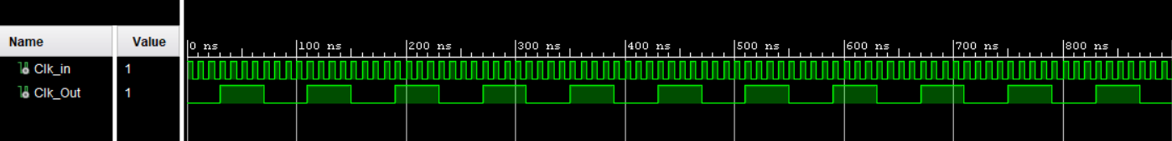

**Register Bank**

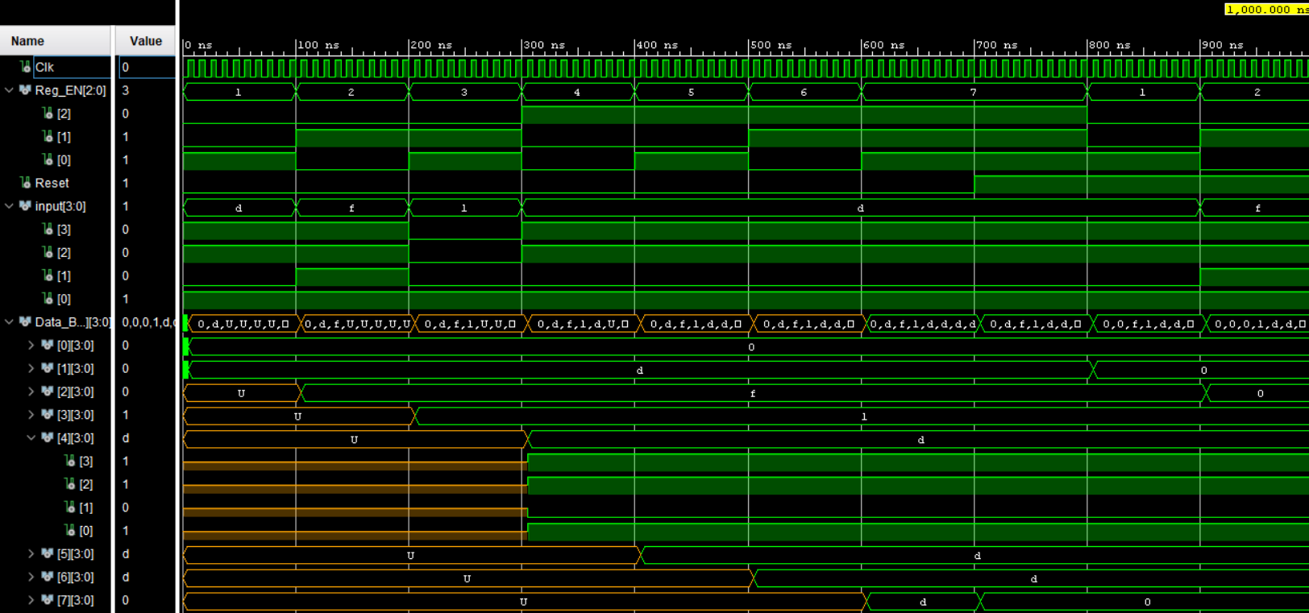

**TB_bit3_Adder.VHDL**

**TB_bit4_Add_Sub_Unit.VHDL**

**NanoProcessor Elaborated Design**

**Implemented Designs**

**NanoProcessor**

**Slow Clock**

**Program Counter**

**Program ROM Elaborated Design**

**Instruction Decoder**

**Register Bank**

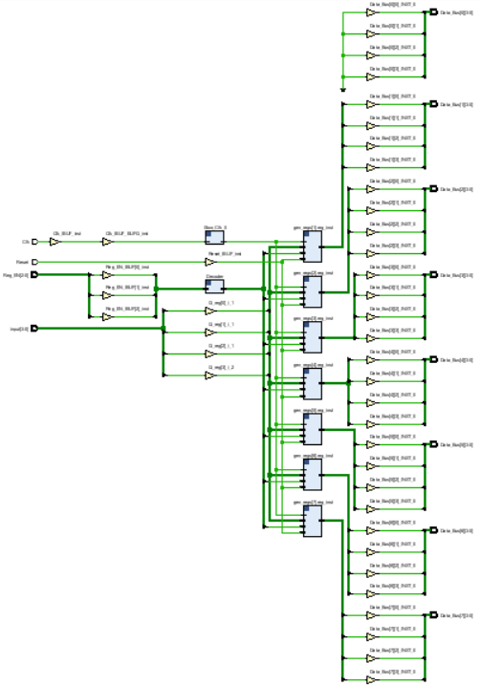

**Register**

**2-way 4-bit Multiplexer**

**3 to 8 Decoder**

**8-way 4-bit Multiplexer**

**Half Adder**

**Full Adder**

**4-bit Add/Sub Unit**

**3-bit Adder**

**2-way 3-bit Multiplexer**

**7 Segment Display**

**Constraints File (Basys3.xdc)**

set_property PACKAGE_PIN W5 [get_ports Clk]

set_property IOSTANDARD LVCMOS33 [get_ports Clk]

create_clock -add -name sys_clk_pin -period 10.00 -waveform {0 5} [get_ports Clk]

## Switches

set_property PACKAGE_PIN V17 [get_ports {change_program}]

set_property IOSTANDARD LVCMOS33 [get_ports {change_program}]

## LEDs

set_property PACKAGE_PIN U16 [get_ports {LED[0]}]

set_property IOSTANDARD LVCMOS33 [get_ports {LED[0]}]

set_property PACKAGE_PIN E19 [get_ports {LED[1]}]

set_property IOSTANDARD LVCMOS33 [get_ports {LED[1]}]

set_property PACKAGE_PIN U19 [get_ports {LED[2]}]

set_property IOSTANDARD LVCMOS33 [get_ports {LED[2]}]

set_property PACKAGE_PIN V19 [get_ports {LED[3]}]

set_property IOSTANDARD LVCMOS33 [get_ports {LED[3]}]

set_property PACKAGE_PIN P1 [get_ports {Zero}]

set_property IOSTANDARD LVCMOS33 [get_ports {Zero}]

set_property PACKAGE_PIN L1 [get_ports {Overflow}]

set_property IOSTANDARD LVCMOS33 [get_ports {Overflow}]

##7 segment display

set_property PACKAGE_PIN W7 [get_ports {S_7seg[0]}]

set_property IOSTANDARD LVCMOS33 [get_ports {S_7seg[0]}]

set_property PACKAGE_PIN W6 [get_ports {S_7seg[1]}]

set_property IOSTANDARD LVCMOS33 [get_ports {S_7seg[1]}]

set_property PACKAGE_PIN U8 [get_ports {S_7seg[2]}]

set_property IOSTANDARD LVCMOS33 [get_ports {S_7seg[2]}]

set_property PACKAGE_PIN V8 [get_ports {S_7seg[3]}]

set_property IOSTANDARD LVCMOS33 [get_ports {S_7seg[3]}]

set_property PACKAGE_PIN U5 [get_ports {S_7seg[4]}]

set_property IOSTANDARD LVCMOS33 [get_ports {S_7seg[4]}]

set_property PACKAGE_PIN V5 [get_ports {S_7seg[5]}]

set_property IOSTANDARD LVCMOS33 [get_ports {S_7seg[5]}]

set_property PACKAGE_PIN U7 [get_ports {S_7seg[6]}]

set_property IOSTANDARD LVCMOS33 [get_ports {S_7seg[6]}]

set_property PACKAGE_PIN U2 [get_ports {anode[0]}]

set_property IOSTANDARD LVCMOS33 [get_ports {anode[0]}]

set_property PACKAGE_PIN U4 [get_ports {anode[1]}]

set_property IOSTANDARD LVCMOS33 [get_ports {anode[1]}]

set_property PACKAGE_PIN V4 [get_ports {anode[2]}]

set_property IOSTANDARD LVCMOS33 [get_ports {anode[2]}]

set_property PACKAGE_PIN W4 [get_ports {anode[3]}]

set_property IOSTANDARD LVCMOS33 [get_ports {anode[3]}]

##Buttons

set_property PACKAGE_PIN U18 [get_ports Reset]

set_property IOSTANDARD LVCMOS33 [get_ports Reset]

**Conclusion**

The project successfully achieved its goal of designing a 4-bit processor capable of executing 4 simple instructions. By developing key subcomponents like the instruction decoder and program counter, we mastered our skills in VHDL implementations. Our approach to the project involved modular design, careful component integration and thorough testing to ensure the reliability and performance of the Nanoprocessor system. The emphasis on teamwork facilitated efficient collaboration and integration of individual contributions of each team member, which resulted in an efficiently functioning nano processor with verified functionality on simulation and development board. Additionally, integrating a user-friendly display for negative values indicates our attention to usability and user experience.